|  |
| --- |
| **Church News**  radiYAte Weekend Away  Young adults weekend away is happening Sept 14-16! Our speaker is James Chen. Registrations still open!  FRESH in August  We'll be running 5 weeks of supper and dialogue for our non-Christian friends starting August 8 in Kingsgrove. Think about whether you'd like to come and who you can invite. To help us prepare for it, and to get an idea of its format, we're running ‘PRE-FRESH' on Wed August 1 at 7.30pm in the hall.  Reachout Missions Conference (Sept 8-9 in Katoomba)  God calls all to partake in His great mission, whether you are looking to go short term/long term or still trying to figure out. ReachOut conference is a good way to learn more about missions and different opportunities available.  See PT (from Bankstown) if interested. You can also RSVP on Facebook: <https://www.facebook.com/events/457380904713427/>  Operation Christmas Child  Give needy children the joy of Christ’s love at Christmas time. Grab a shoebox or two and have fun shopping. Please bring back to church by Sunday 7th October. Contact PT if you have questions.  Evangelism Tabletalk  We want to be better at sharing the good news of Jesus but how do we do it? What do you do when the hard questions come up? Come join us as we discuss the questions we face and how we should respond. 12th August 9:30am at All Good Things Cafe. See Grace Yam for more info. |

|  |  |  |  |  |  |  |  |
| --- | --- | --- | --- | --- | --- | --- | --- |
| **Upcoming Events**  August  1st - Pre-FRESH (7.30pm Kingsgrove hall)  5th – Congregational Prayer Meetings (10am)  8th – FRESH begins (Every Wed for 5 weeks, 7.30pm Kingsgrove)  12th – Evangelism Table Talk (9.30am All Good Things Café)  18th – RICE Rally | **Stay Connected**   |  |  | | --- | --- | |  | fb.com/swechurch | |  | @swechurch | |  | swec.org.au/newsletter | |

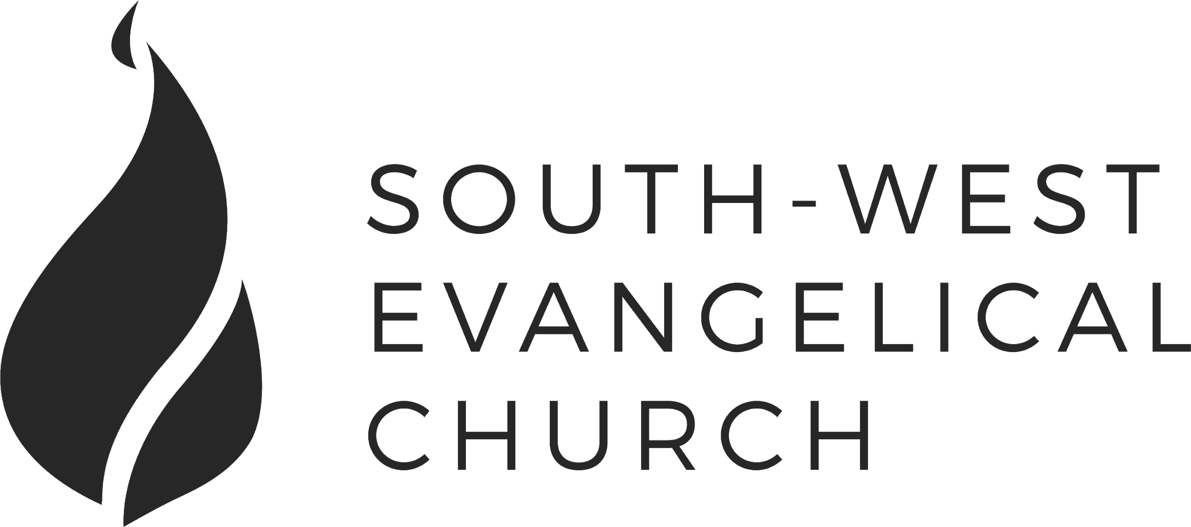

Sunday, 29 July 2018 | 11am English | [www.swec.org.au](http://www.swec.org.au)

Pastor Peter Ko | 0433 493 488 | pko@swec.org.au

What we’ll be doing during our time together

1. Worship

We’ll be worshipping God through song, prayer and by hearing His word.

Today’s confession prayer

Lord God,  
we have sinned against you;  
we have done evil in your sight.  
We are sorry and repent.  
Have mercy on us according to your love.  
Wash away our wrongdoing and cleanse us from our sin.  
Renew a right spirit within us  
and restore us to the joy of your salvation,  
through Jesus Christ our Lord. Amen.

Bible reading - 1 Samuel 1:1-3A, 9-17, 20

2. Community

An opportunity to get updated with what’s happening at SWEC!

3. Prayer

We’ll be praying for various needs in our church, the wider community, and the world.

4. God’s Word

Today’s sermon will be given by Peter Ko.

5. Response

An opportunity for us to respond by singing, through holy communion, and by financial giving.

6. Blessing & Sending  
Go with God’s blessing to love and serve him and the world.

|  |  |  |
| --- | --- | --- |
| **Pastors**  Peter Ko (Lead Pastor)  Stephen Fei  Dom Cheung  Karen Ko | **Elders**  Johnson Lee  Andrew Lim  Kirby Wong  Nelson Siu  board@swec.org.au | **Student Pastors**  Andrew Hayes  James Hoey  **Ministry Intern**  Lisa Truong |

To Eat or Not To Eat

1 Corinthians 8

Introduction

1. The Issue in Corinth
2. The Gospel is the Problem, and the Solution
   1. The Gospel liberates
   2. The Gospel leveller
3. Gospel Living & Gospel Love
   1. Don’t over-apply
   2. Work out when you need to do the hard work
   3. In everything: Love for others and God’s glory

Zacpages is ending its service at the end of this month.

Please export any saved notes that you have written on   
Zacpages before the end of the month. Thank you!

